FLOWGORITHM
1. Read the start hour and end hour of a class. Validate the input
and calculate duration, assuming both are on the same day.
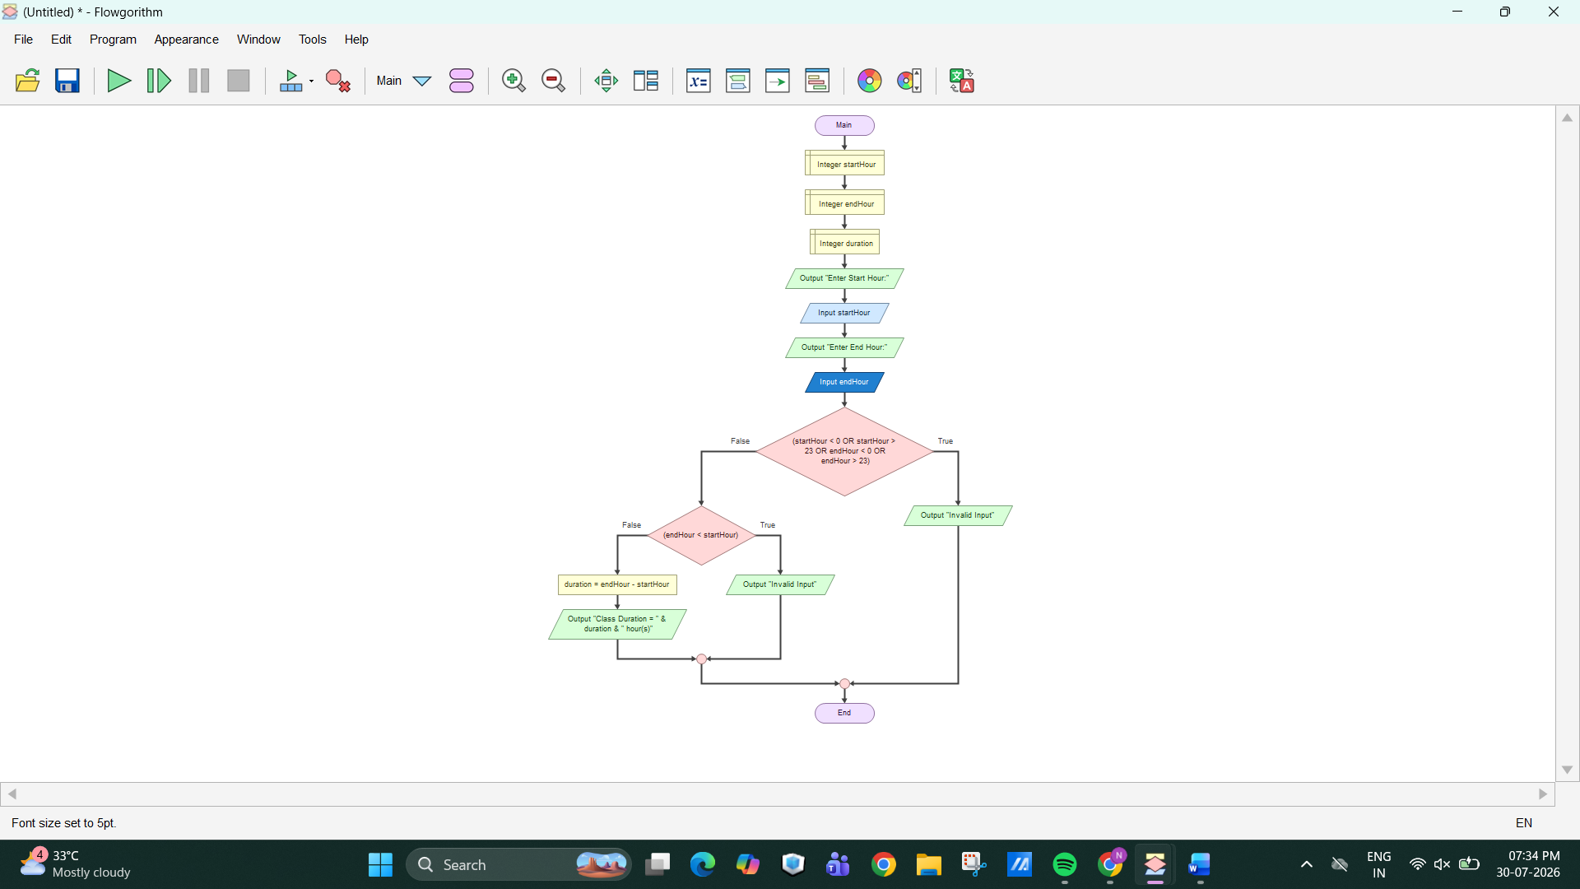OUTPUT: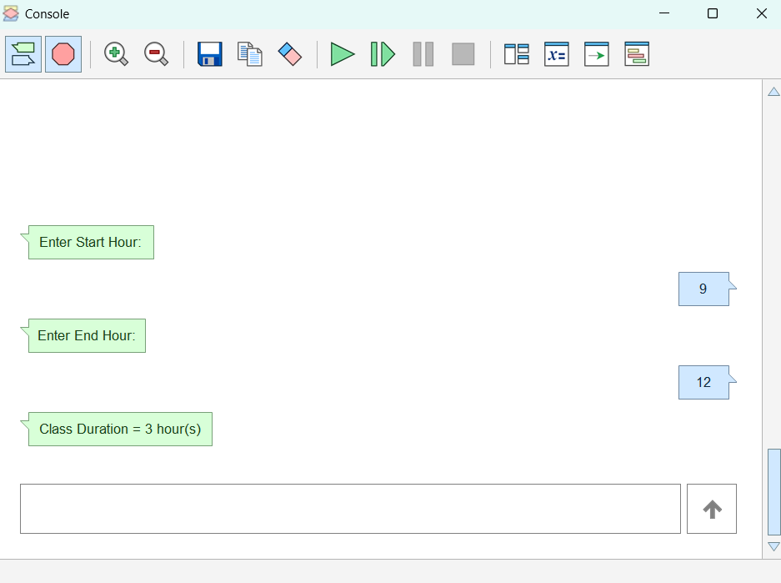

2. Read N integers and divide them into two arrays: values below
the average and values equal to or above the average.
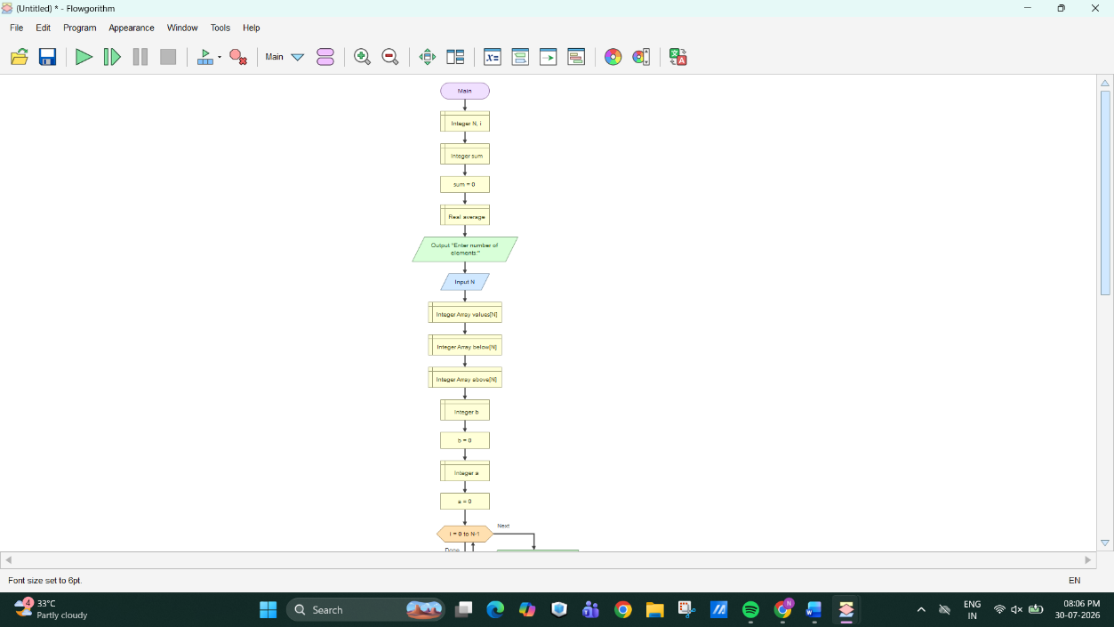
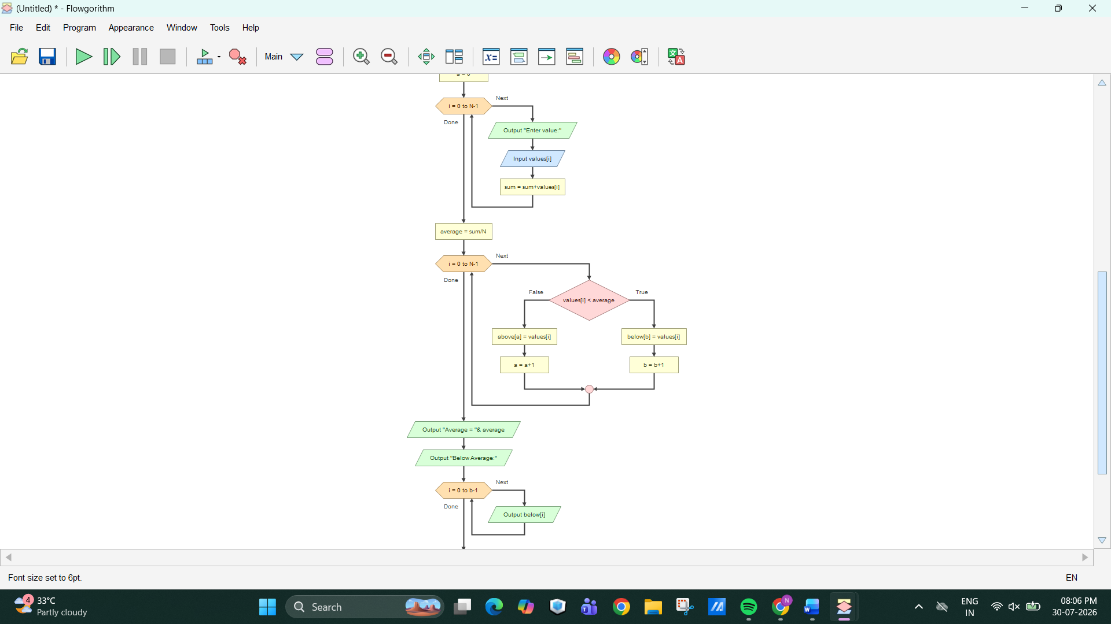

OUTPUT:
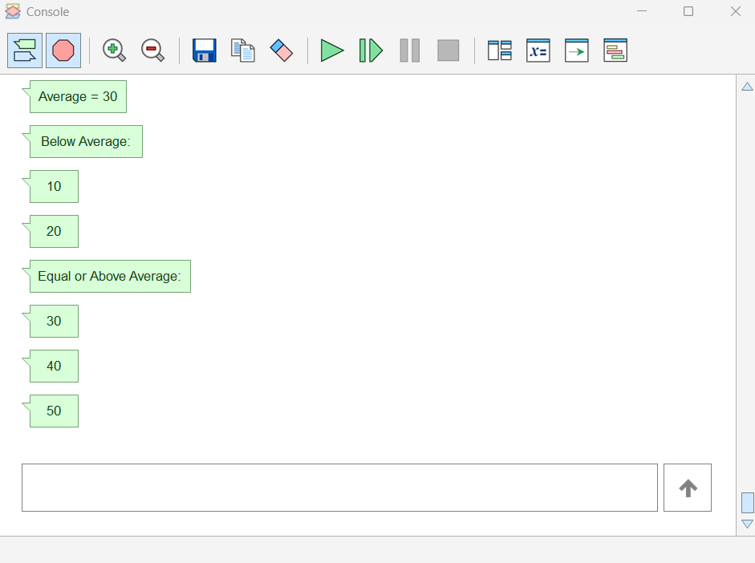
3. Design a game-character flowchart with Warrior, Archer, and
Healer producing different action values for attack or support.
Relate it to polymorphism.
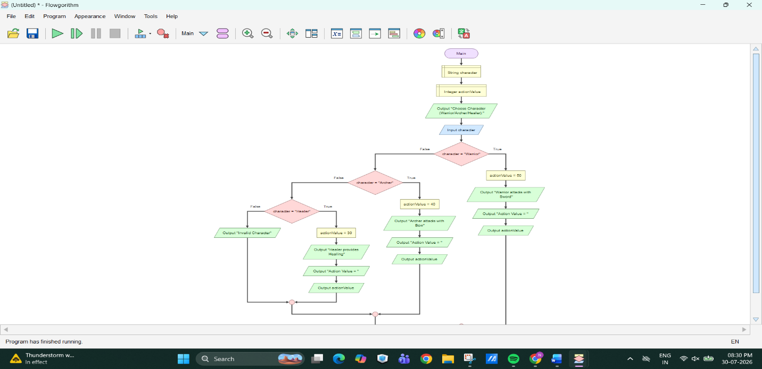

OUTPUT:
